# SQL QUERY

**CREATING A TABLE**

CREATE TABLE STUDENTNEW(Reg_No number(20), Stud_Name VARCHAR(20),DATE_OF_BIRTH DATE)

**OUTPUT:**

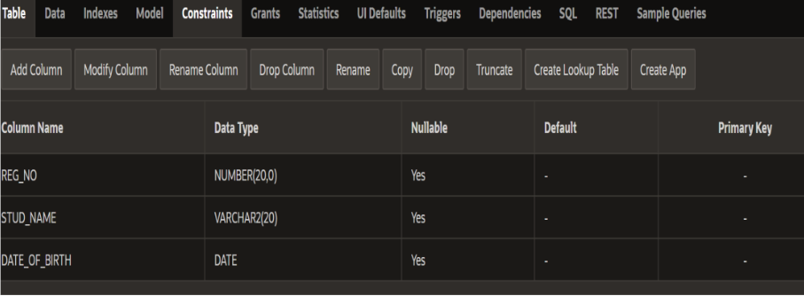

**ADD NEW FIELD TO THE TABLE:**

ALTER TABLE STUDENTNEW

ADD BLOOD_GROUP VARCHAR(30);

**OUTPUT:**

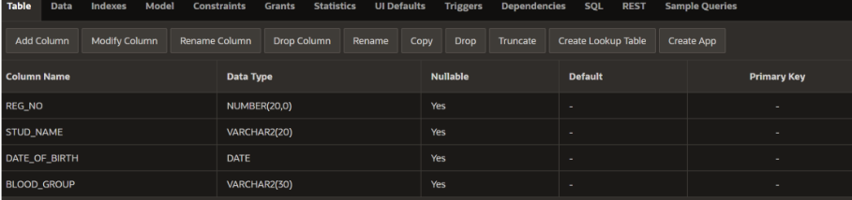

**CREATING A TABLE:**

CREATE TABLE STUDENTNEW(Reg_No number(20), Stud_Name VARCHAR(20),DATE_OF_BIRTH DATE)

**OUTPUT:**

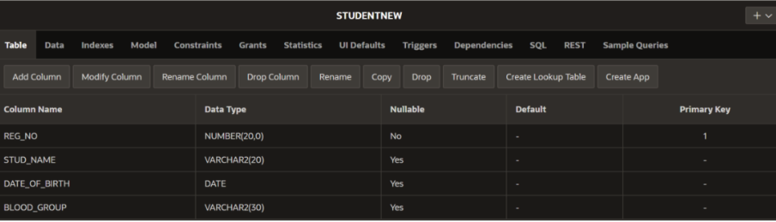

**INSERTING:**

INSERT INTO STUDENTNEW VALUES(192371030,'SANDHIYA',SYSDATE,'B positive');

INSERT INTO STUDENTNEW VALUES(192325049,'HARSHITHA',SYSDATE,'O positive');

OUTPUT:

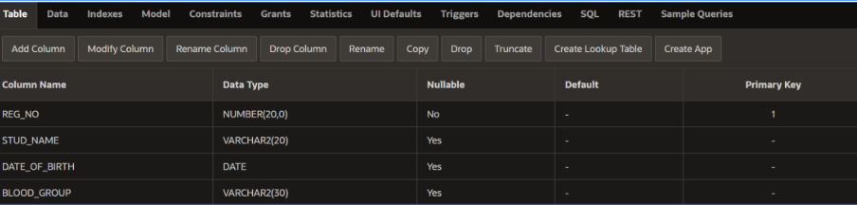

# SELECT:

# SELECT REG_NO,STUD_NAME FROM STUDENTNEW;

**OUTPUT:**



**DELETE:**

DELETE FROM TABLENAME WHERE BLOOD=’B

**CREATE TABLE PERSON(PERSONAL_ID NUMBER(15) PRIMARY KEY, P_NAME VARCHAR(15), AGE INT(5),GENDER VARCHAR(10),ADDRESS VARCHAR(50));**

SET THE FOREIGN KEY:

ALTER TABLE P_ORDER

ADD FOREIGN KEY(PERSON_ID) REFERENCES PERSON(PERSON_ID);



**ALTER TABLE PERSON**

**ADD PRIMARY KEY(PERSON_ID);**

CREATE THE TABLE 2:

CREATE TABLE P_ORDER(ORDER_ID NUMBER(10),PERSON_ID NUMBER(10), ITEM_NAME VARCHAR(15), ORDER_DATE NUMBER(5));

ALTER TABLE PERSON

ADD PRIMARY KEY(OREDR_ID);



CREATE TABLE orders(order_id int PRIMARY KEY,

person_id int NOT NULL,

order_amount numeric);

ALTER TABLE orders

ADD FOREIGN KEY (person_id) REFERENCES personNew(person_id);

